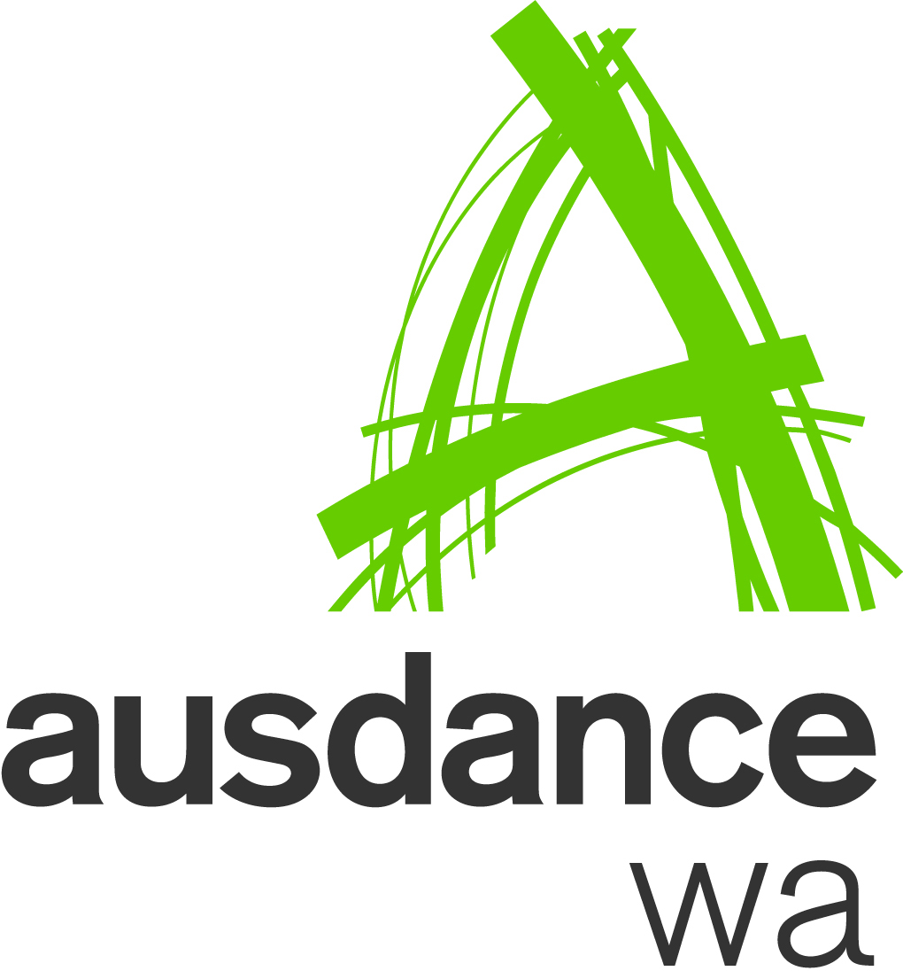
Australian Dance Week 2016:
30 April – 8 May
Presented by Ausdance WA, Act-Belong-Commit
and supported by the City of Perth

Ausdance WA wants YOU to join in the fun!

Showcase your dance films
in our Act-Belong-Commit DANCE FILMS 2016 project
as part of the Act-Belong-Commit DANCE 100 program.

The Act-Belong-Commit DANCE FILMS will be a free broadcast of dance films by 15-20 filmmakers from all over Western Australian. Ausdance WA is planning a minimum of ten screenings to take place during the Act-Belong-Commit DANCE 100 program in up to ten locations:

- Northbridge
- Mandurah
- Kalgoorlie
- Merredin
- Busselton
- Denmark
- Bunbury
- Carnarvon
- Broome
- Esperance

At least eight screenings will take place in regional centers and rural communities throughout Western Australia, and there will be five screenings at the James Street Amphitheatre Screen in the Perth Cultural Centre (2 - 6 May) as part of Australian Dance Week 2016.

Film Submission Criteria
The Act-Belong-Commit DANCE FILMS must be suitable for general community viewing. Although we welcome all films, please adhere to the criteria when considering submitting your film for the 2016 program.
- Media content can include short films, dance clips or promotional shorts of up to 15 minutes in length;
- You may submit more than one film. Please indicate your preference, in the case that Ausdance WA receives more content than it can include in the program schedule. Ausdance WA will curate the overall film program;
- Media content must be suitable for viewing for the general community. Content containing nudity, graphic or audio references to smoking, suicide, alcohol, abuse, violence or blood, and swearing will not be accepted;
- You have exclusive copyright of the media, as either the producer or the executive producer of the media. Please sign the copyright section on the EOI form prior to submitting;
- Media content can be submitted in hard copy (ie DVD, CD, thumb drive) or preferably via email (ie vimeo, mp4, dropbox link) to the Projects Manager, po.wa@ausdance.org.au Please note that the better the initial quality of the video is, the better the end result will be;
- All submissions must be accompanied with a completed EOI form providing details of the film;
- All media content is to be submitted to the Projects Manager by 5pm 8 March 2016. Any media content received after this date will not be included.
AUSTRALIAN DANCE WEEK 2016: 30 April – 8 May
Presented by Ausdance WA, Act-Belong-Commit
and supported by the City of Perth

EXPRESSION OF INTEREST
Act-Belong-Commit DANCE FILMS
2 – 6 May 2016

Contact Name:
Studio/Company Name: |  | Membership # (If Applicable):
Mobile: |  | Phone (home/work):
Email:
Postal Address: |  |  | Postcode:

Film 1
Title of Work:
Type of film:
Length of film:
Summary of film:
Dance style/genre:

Film 2
Title of Work:
Type of film:
Length of film:
Summary of film:
Dance style/genre:

Film 3
Title of Work:
Type of film:
Length of film:
Summary of film:
Dance style/genre:

COPYRIGHT CLEARANCE FOR MEDIA

Applicants must ensure that they have the appropriate copyright permissions for any media (both visual and audio) submitted to Ausdance WA. This means that the applicant is either the copyright holder of the media, or has obtained permission from the copyright holder to screen the media publicly. Ausdance WA and the Northbridge Piazza reserve the right to refuse media if appropriate copyright ownership or permission cannot be demonstrated.

I am/My organisation is the exclusive copyright holder of this media, as either the producer or the executive producer of the media
I have/My organisation has obtained express written permission from the copyright holder to screen this media in a public space
Other: Please provide details below
DECLARATION: |  | I accept that I hold full responsibility for ensuring that correct copyright permissions for the submitted media have been acquired.
SIGNATURE: |  |  | DATE:

