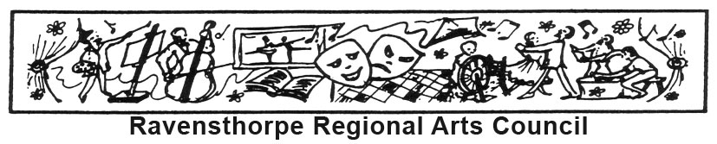

ABN 60 557 238 342
_______________________________________________________________________________________________
President: Ainsley Foulds Post Office Box 396
Vice President: Jenny Chambers Hopetoun WA 6348
Secretary: Fay O’Brien raveaboutarts.blogspot.com.au
Treasurer: Dianne Belli www.facebook.com/Raveaboutarts
Coordinator: Kirsty Duffy 0438 945 405 rraccoordinator@westnet.com.au

Dance Teacher Wanted

Must have sense for adventure and the taste for new and invigorating projects!

Ravensthorpe Regional Arts Council (RRAC) wish to host a dance artist in residence to engage the community in dance (classes) and performance. RRAC will be engaging the surrounding communities by including six schools: Hopetoun, Ravensthorpe, Jerramungup, Munglinup, Jerdacuttup and Lake King. By forging a partnership with schools, we are making dance accessible to all. Additionally, adult classes will be offered to the communities. Community engagement will also occur through mentorship of local artists and teachers who wish to extend their dance capabilities. The resident dance artist will work with selected locals in each town to encourage participation and upskilling in various forms.

A 5-week residency will occur in Term 4 2017.

Contract: 5 Weeks in 2017 (38 hours per week)
Dates: Within weeks 3 (Beginning 23rd October) and
Week 8 (beginning 27th November) of School Term 4, 2017

Contract will start with travel to Hopetoun on a Wednesday, and will end with return travel on a Wednesday. Please refer to Dance Teacher Schedule.

Accommodation: Will be provided in-kind in Hopetoun six nights a week and;
in Jerramungup one night per week

Wages: $1145.70 per week pre-tax
Superannuation: 9.5%
Meal allowance: $274.65 per week will be paid
Incidentals: $75.67 per week will be paid

Travel: Travel allowance of $1012 will be paid for return trip to the region.
Must have own means of transportation (vehicle).
Travel allowance: Travel allowance of 880 kms/week @ 0.88c for four weeks of school visits will be paid. ($774.40 per week)

Qualifications: Preferably holds a Diploma of Education (not essential)
Experience working in a school environment or with children
Must have current Working with Children Card

Dance styles: Open to suggestion. Hip Hop and Acro have been very popular in Hopetoun.

2017’s Dance Residency will be followed by two 9-week dance artist residencies in 2018 and two 9-week residencies 2019 subject to funding. The dance artist in residence does not have to commit to the ongoing project, (throughout 2018 and 2019) but that option is available.

To apply: Contact Ravensthorpe Regional Arts Council Coordinator: Kirsty Duffy
M 0438 945 405
E rraccoordinator@westnet.com.au

Applications close: Friday 15 September 2017

Who are Ravensthorpe Regional Arts Council?

http://raveaboutarts.blogspot.com.au/p/about.html

https://www.facebook.com/Raveaboutarts

Information about the region:

https://www.hopetounwa.com/visitor-directory

https://fitzgeraldcoast.com.au/

http://www.ravensthorpe.wa.gov.au/tourism.aspx

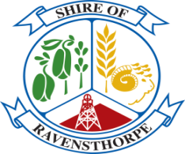
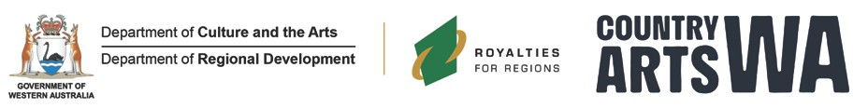

Ravensthorpe Regional Arts Council receives core funding from Country Arts WA, which receives funding from the State Government through the Department of Culture and the Arts and Lotterywest.

The Regional Arts Partnership Program is supported by the Departments of Culture and the Arts and Regional Development, Royalties for Regions and Country Arts WA.

